RIX2024 - Batch 1 - Docker Practical Assessment
12576 Nisanth Saravanan

Co-Living Expense Manager

W3H Analysis

Project Title: Co-Living Expense Manager
What? |  | How?
1. What are the necessary modules?  A: Modules Needed:  1) Login and Registration.  2)User Dashboard.  2. What are the necessary functionalities of Login and Registration Modules?  A: Login and Registration Module:  1) Register User.  2) Login as User.  3. What are the necessary functionalities of User Dashboard?  A: User Dashboard:  1) Perform CRUD Operation with Expenses.  2) Filter Expenses.  4. What are the tables needed?  A: Tables Required:  - Expenses  - Users  5. What are the fields of user table?  A: Fields of Users table:  - Id (Primary Key) - int  - Name – string  - Contact – int  - Password – string  6. What are the fields of the Expenses table?  A: Fields of Expenses Table:  - Id (Primary Key) - int  - Name – string  - Type – string  - Description - string  - Amount – float/decimal  7. What are the must have dependencies?  A: Dependencies:  - axios  - react-router-dom  8. What are the validations in the application?  A: Overall validations list:  - Frontend simple JS Validations.  - Server Side validations.  - Form Validations. |  | Login and Registration Module:  1) Register User:  Method 1: Use Simple Form Page.  Method 2: Use a Modular Form Page.  Method 3: Use Google OAuth and other 3rd party services.  2) Login as User:  Method 1: Use Simple Form.  Method 2: Use a Modular Form.  Method 3: Use 3rd party services.  User Dashboard:  1) Perform CRUD Operation with Expenses:  Method 1: Use Simple Forms and Buttons to perform CRUD.  Method 2: Have separate pages for each operation  Method 3: Use Modals.  2) Filter Expenses:  Method 1: Use a simple search bar.  Method 2: Have tables and sorting buttons.  Method 3: Have a separate page to pick out exact results.
Login and Registration Module:  1) Register User:  Method 1: Use Simple Form Page.  A: Since the overall scale of the application is small and data needed is rather minimal, it’s wise to stick with traditional forms.  2) Login as User:  Method 1: Use Simple Form.  A: Since the overall scale of the application is small and data needed is rather minimal, it’s wise to stick with traditional forms.  User Dashboard:  1) Perform CRUD Operation with Expenses:  Method 1: Use Simple Forms and Buttons to perform CRUD.  A: Since the overall scale of the application is small and data needed is rather minimal, it’s wise to stick with traditional forms.  2) Filter Expenses:  Method 1: Use a simple search bar.  A: Effective as it may, the simple input field can be directly mapped with the Expenses that are being displayed. |  | Login and Registration Module:  1) Register User:  Method 2: Use a Modular Form Page.  A: Increases the complexity of the app, and also the fact that the number of needed inputs in rather minimal.  Method 3: Use Google OAuth and other 3rd party services.  A: Valid method but due to the scale of the application, this method is seemingly overkill.  2) Login as User:  Method 2: Use a Modular Form.  A: Increases the complexity of the app, and also the fact that the number of needed inputs in rather minimal.  Method 3: Use 3rd party services.  A: Valid method but due to the scale of the application, this method is seemingly overkill.  User Dashboard:  1) Perform CRUD Operation with Expenses:  Method 2: Have separate pages for each operation.  A: Since the admin needs all information in one place and also that the number of operations they can do is limited, it is best to have a single page control centre type.  2) Filter Expenses:  Method 2: Have tables and sorting buttons.  A: This method is also viable but not selected due to the slight increase in the number of code needed for its execution.  Method 3: Have a separate page to pick out exact results.  A: Having the all the data displayed in one page and search functionality in another is not idle. Hence, this method is rejected.
Why? |  | Why Not?

Output Screenshots

Docker Desktop – Initial

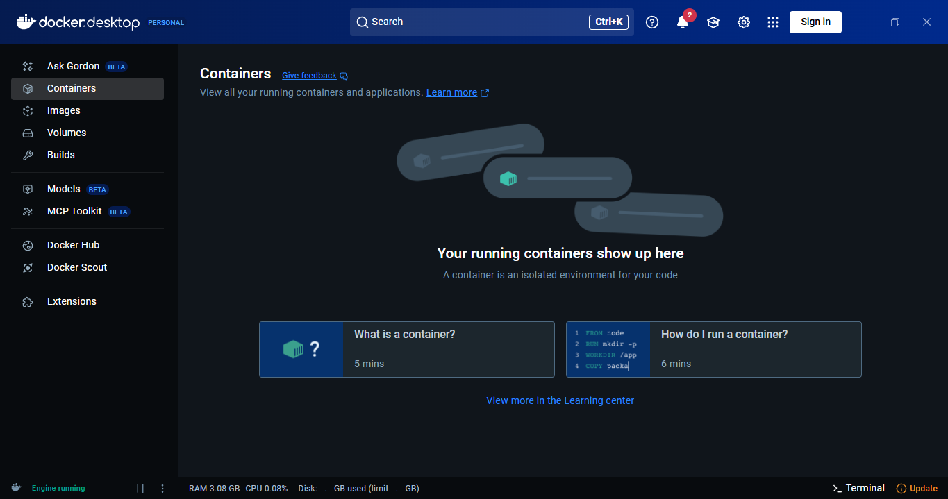

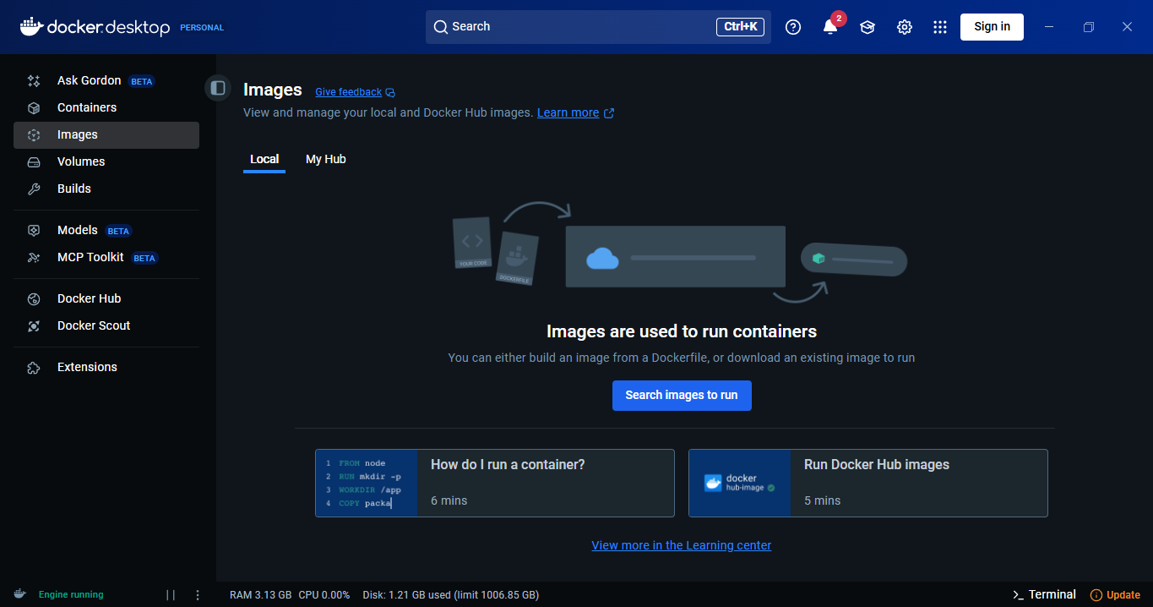
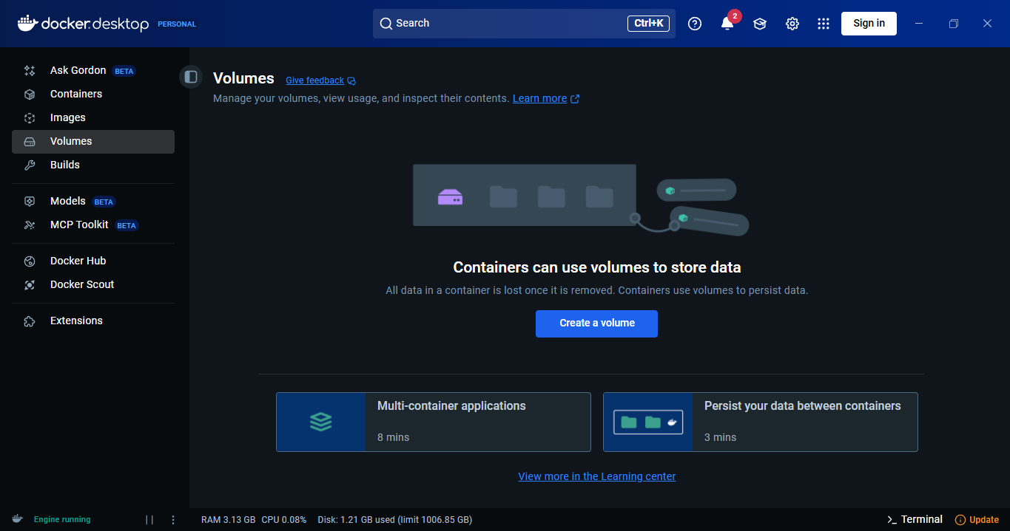

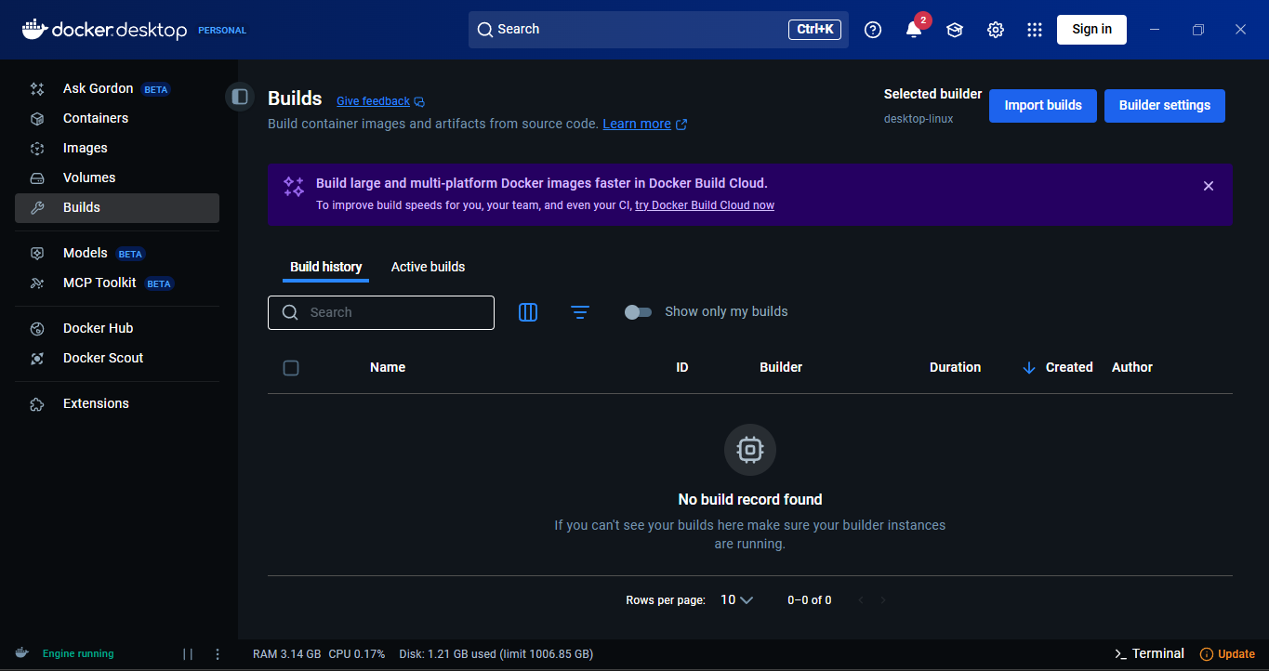
Running the Docker-Compose

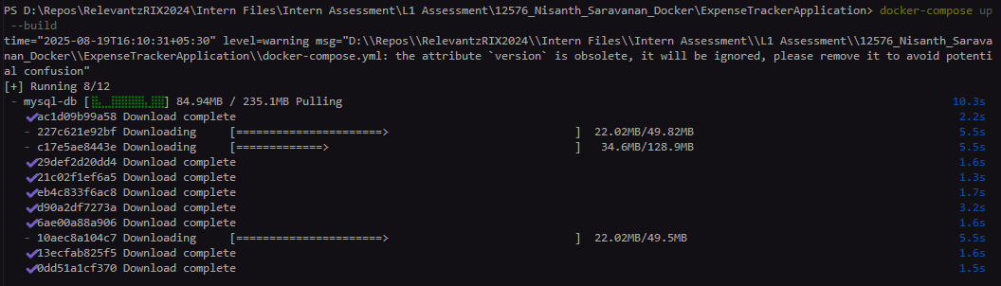

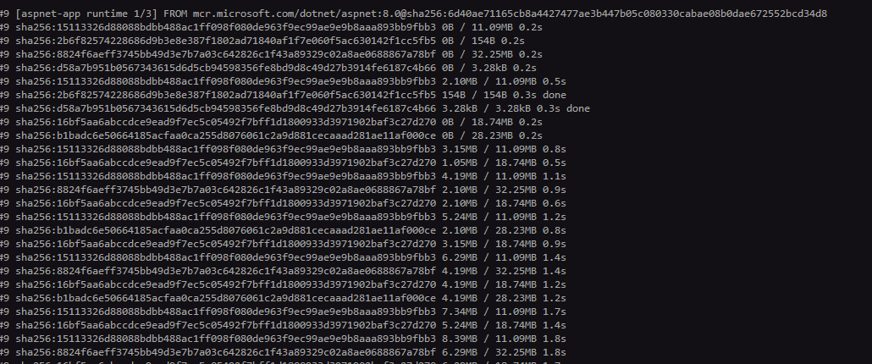

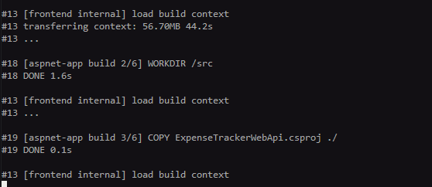
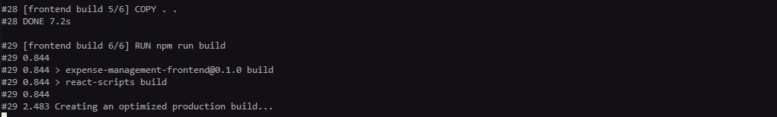

Success

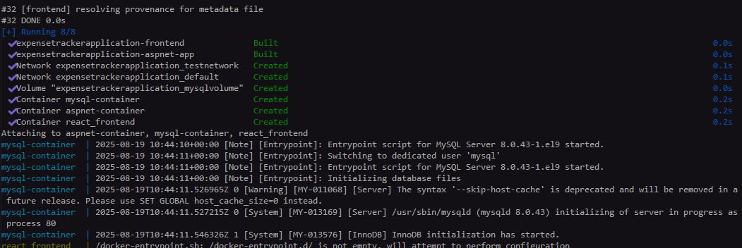
Docker Desktop After a Successful Run

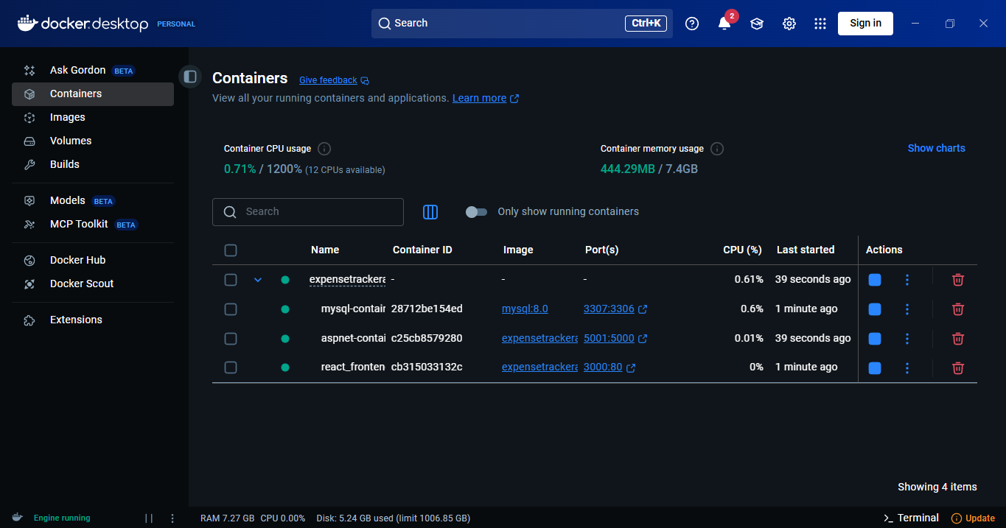

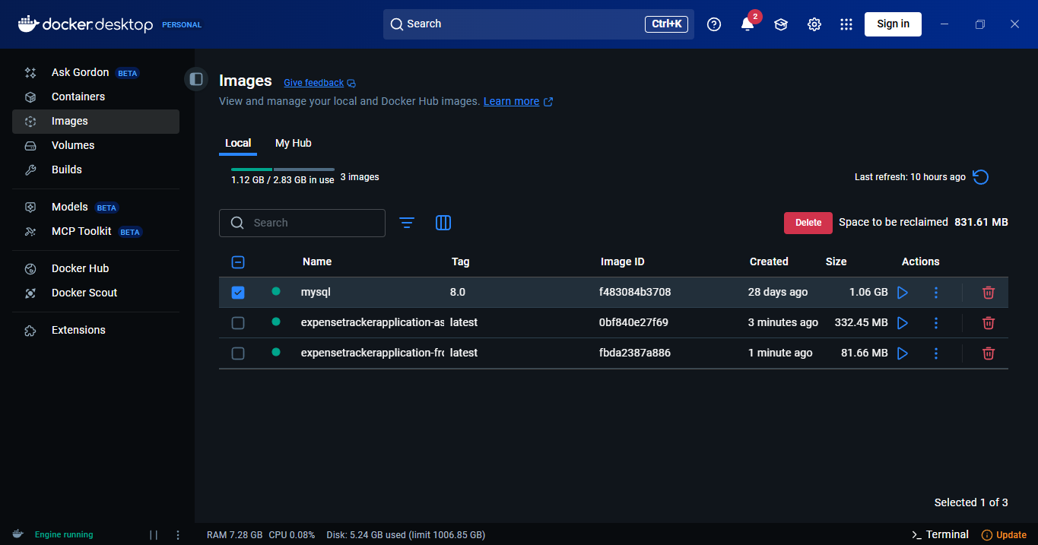

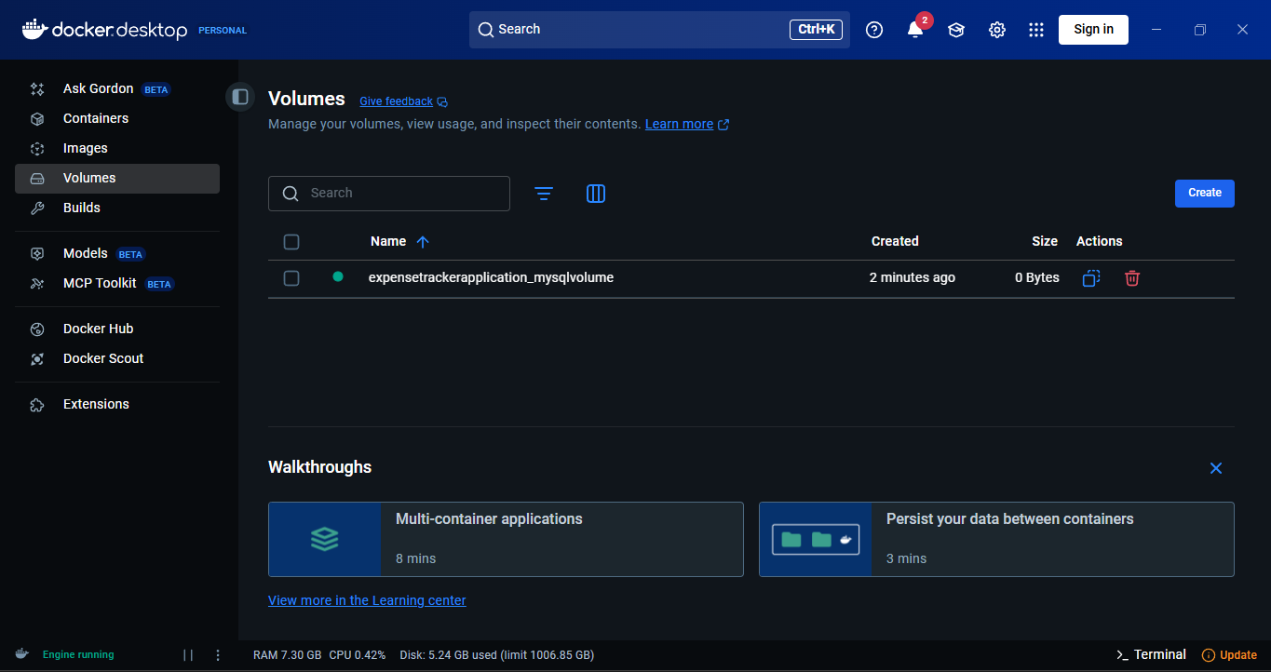

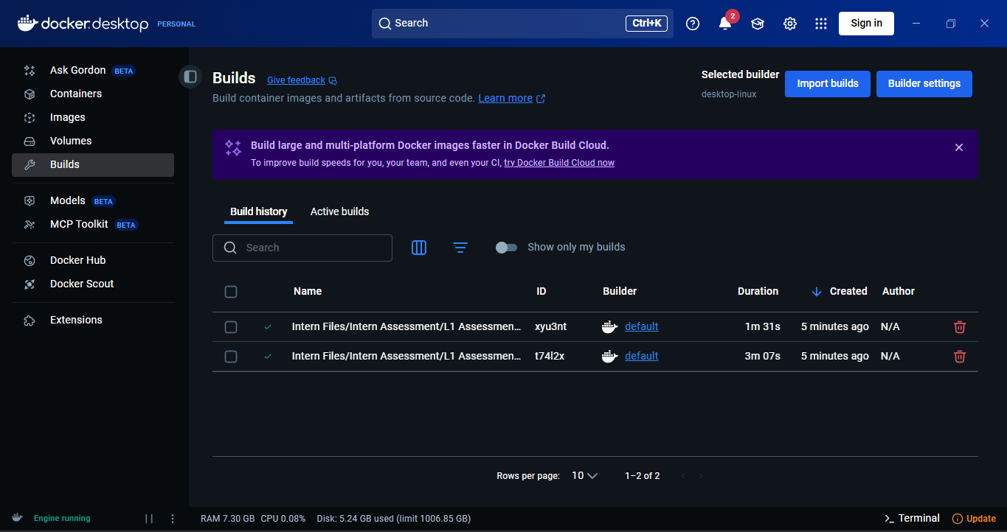
Containerized Outputs

Database

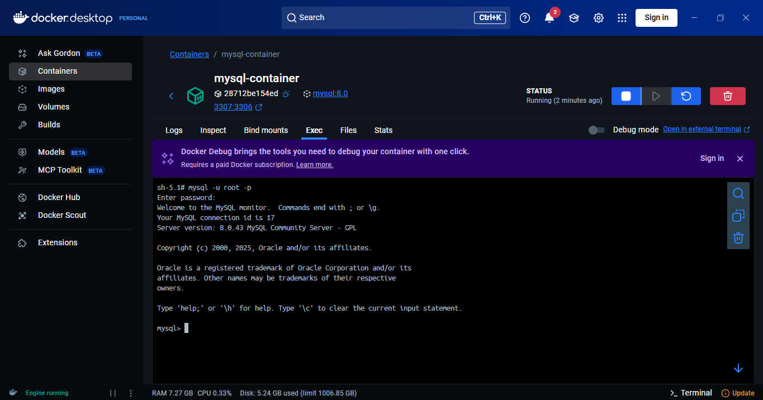

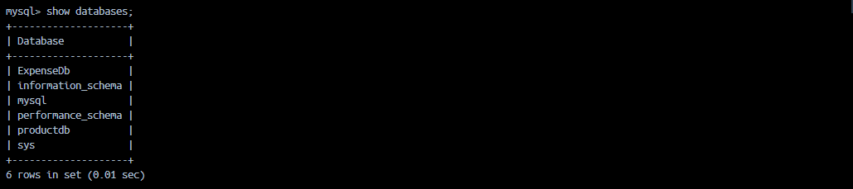

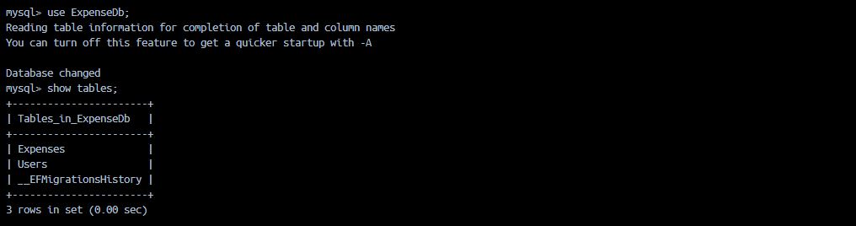
Web API

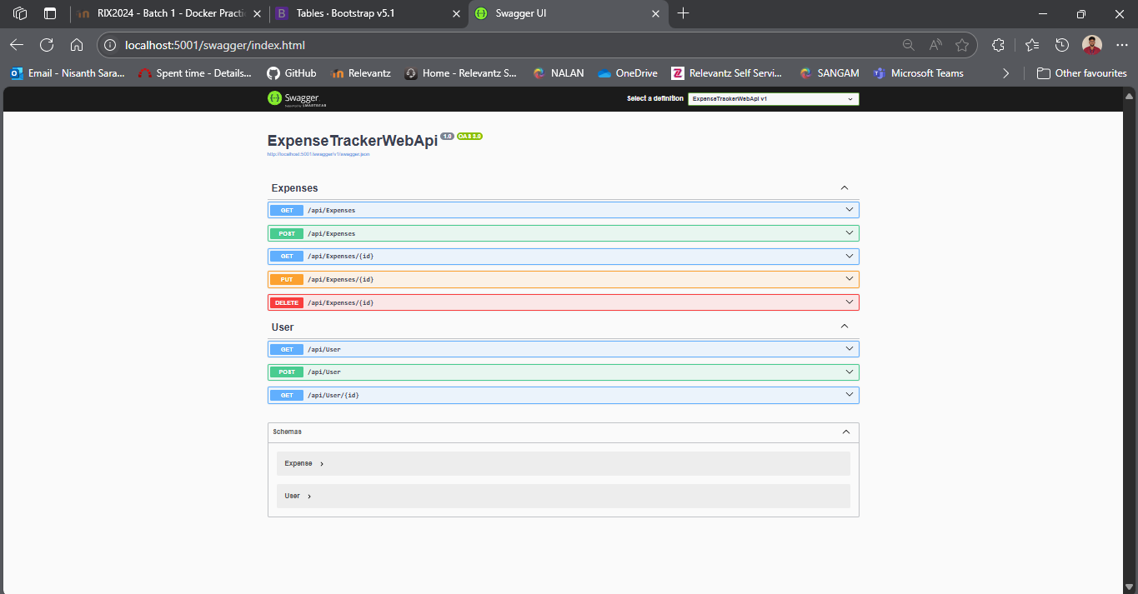

React Frontend

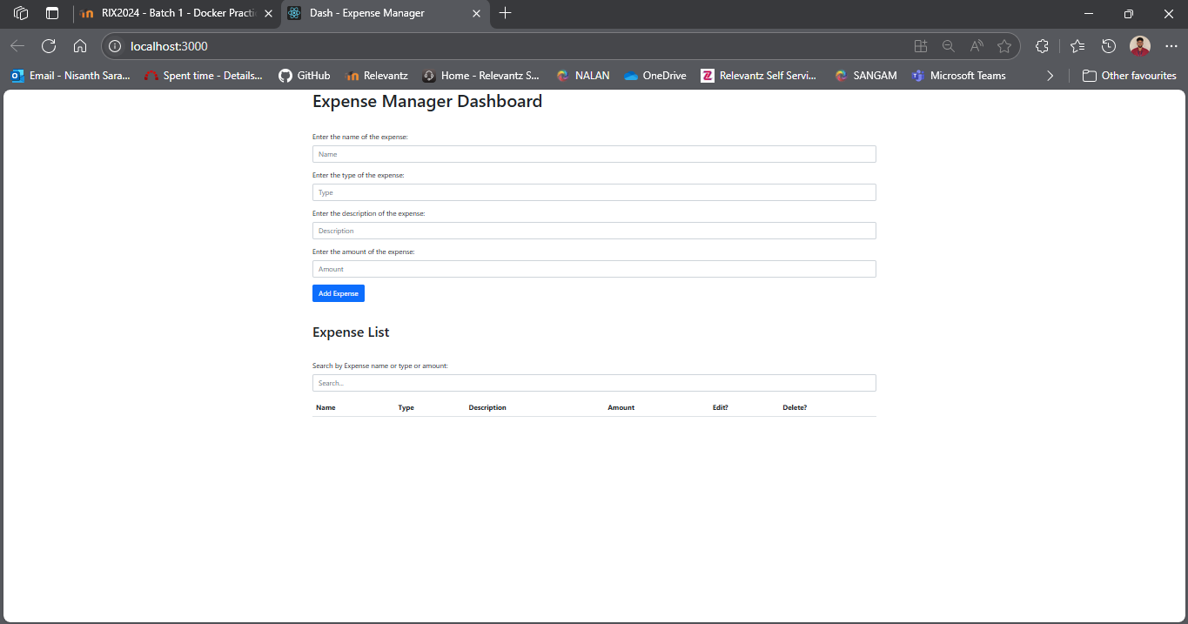
CRUD Operations

Create - Without Description

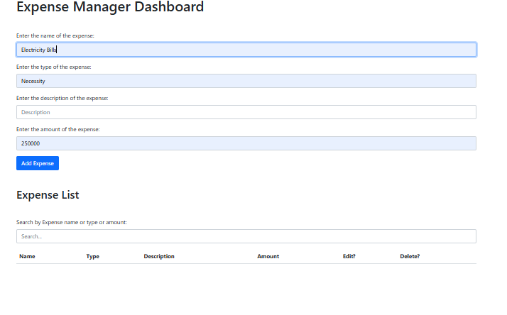

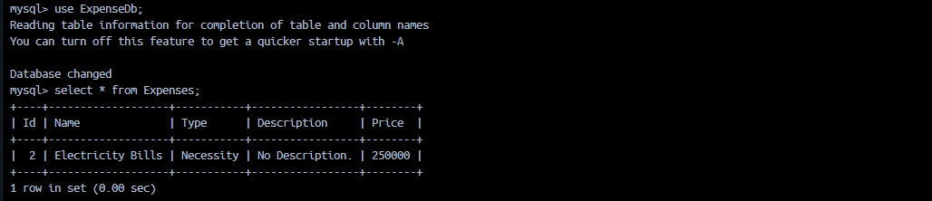

Create – With Description

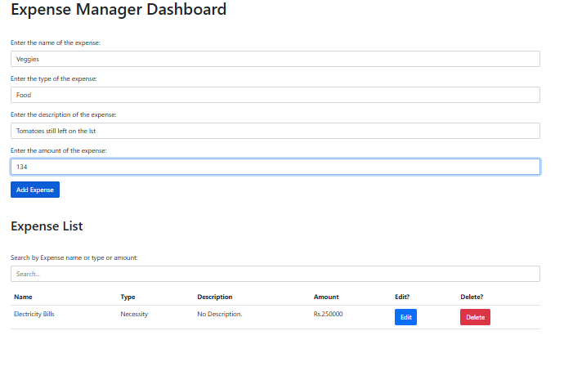

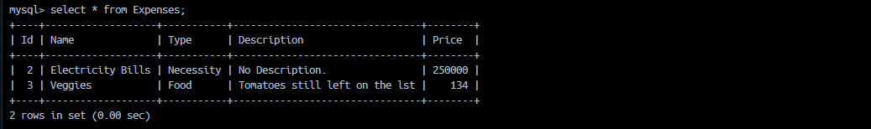
Edit

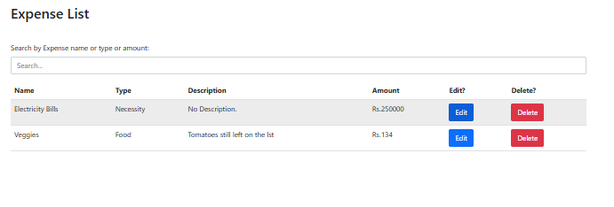

From
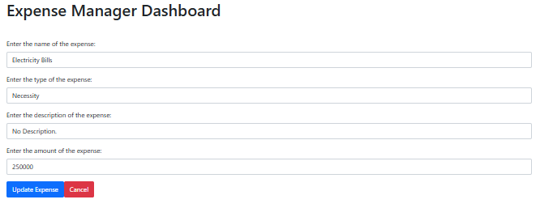

To
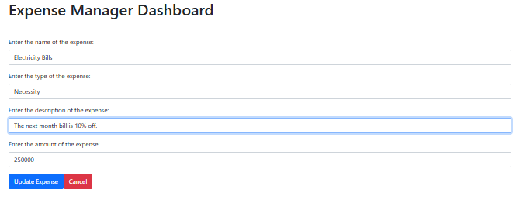
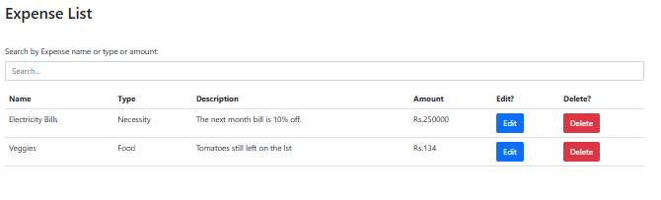

From

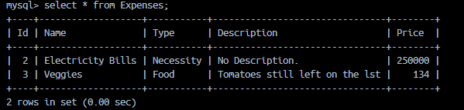

To

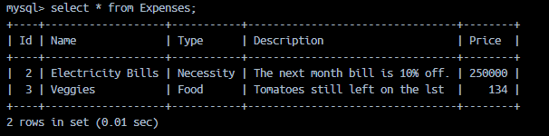
Delete

Before



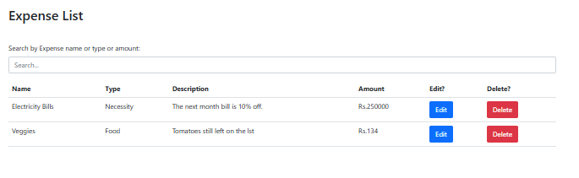

After

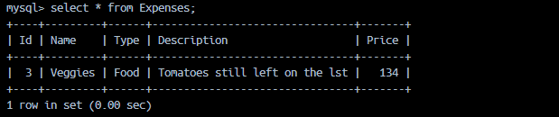

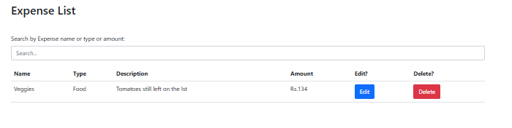
Searching

Sample Data

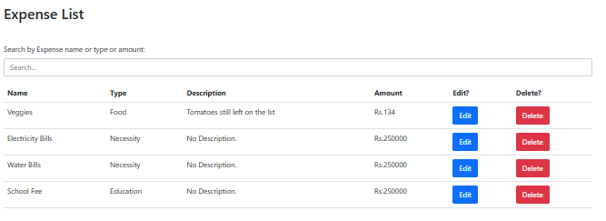

Searching By Name

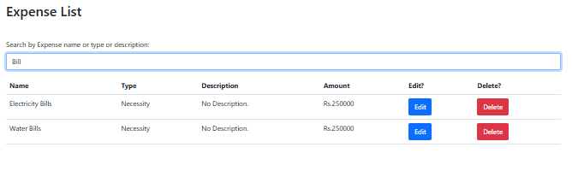

Searching By Type

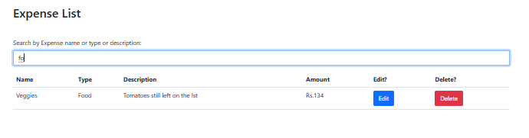

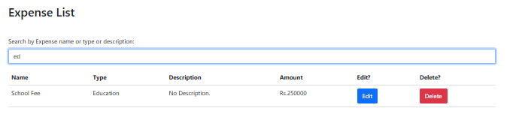

Searching By Description

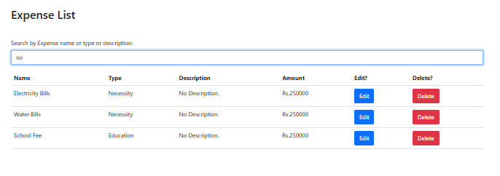

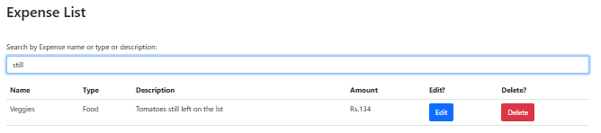
Codebase

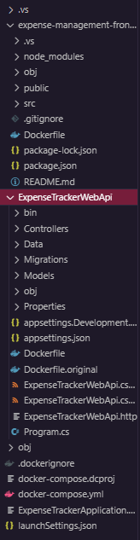
docker-compose.yml

version: "3.9"
services:

aspnet-app:
build:
context: ./ExpenseTrackerWebApi
dockerfile: Dockerfile
container_name: aspnet-container
ports:
- "5001:5000" # Host:Container port mapping
depends_on:
- mysql-db
environment:
- ASPNETCORE_ENVIRONMENT=Development
- ASPNETCORE_URLS=http://+:5128
- ConnectionStrings__DefaultConnection=Server=mysql-db;Database=ExpenseDb;User=root;Password=123456;Port=3306
networks:
- testnetwork
restart: on-failure

frontend:
build:
context: ./expense-management-frontend
container_name: react_frontend
ports:
- "3000:80"
depends_on:
- aspnet-app

mysql-db:
image: mysql:8.0
container_name: mysql-container
restart: always
environment:
MYSQL_ROOT_PASSWORD: 123456
MYSQL_DATABASE: productdb
ports:
- "3307:3306"
volumes:
- mysqlvolume:/var/lib/mysql
networks:
- testnetwork

networks:
testnetwork:

volumes:
mysqlvolume:

.dockerignore

**/.classpath
**/.dockerignore
**/.env
**/.git
**/.gitignore
**/.project
**/.settings
**/.toolstarget
**/.vs
**/.vscode
**/*.*proj.user
**/*.dbmdl
**/*.jfm
**/azds.yaml
**/bin
**/charts
**/docker-compose*
**/Dockerfile*
**/node_modules
**/npm-debug.log
**/obj
**/secrets.dev.yaml
**/values.dev.yaml
LICENSE
README.md
!**/.gitignore
!.git/HEAD
!.git/config
!.git/packed-refs
!.git/refs/heads/**

Back-end ASP .NET Web API

DockerFile

# Build stage
FROM mcr.microsoft.com/dotnet/sdk:8.0 AS build
WORKDIR /src

# Copy and restore dependencies
COPY ExpenseTrackerWebApi.csproj ./
RUN dotnet restore

# Copy the rest of the source code
COPY . ./
RUN dotnet publish -c Release -o /app/publish

# Runtime stage
FROM mcr.microsoft.com/dotnet/aspnet:8.0 AS runtime
WORKDIR /app

# Copy published output from build stage
COPY --from=build /app/publish .

# Expose port 5000 for the API
EXPOSE 5000

# Set environment variable for ASP.NET Core to listen on port 5000
ENV ASPNETCORE_URLS=http://+:5000

# Run the application
ENTRYPOINT ["dotnet", "ExpenseTrackerWebApi.dll"]

Models

User

using System.ComponentModel.DataAnnotations;

namespace ExpenseTrackerWebApi.Models
{
public class User
{
[Key]
public int Id { get; set; }

public string? Name { get; set; }

public int? Contact { get; set; }

public string? Password { get; set; }
}
}

Expense

using System.ComponentModel.DataAnnotations;

namespace ExpenseTrackerWebApi.Models
{
public class Expense
{
[Key]
public int Id { get; set; }

public string? Name { get; set; }

public string? Type { get; set; }

public string? Description { get; set; }

public float? Price { get; set; }
}
}

Data

using Microsoft.EntityFrameworkCore;
using ExpenseTrackerWebApi.Models;

namespace ExpenseTrackerWebApi.Data
{
public class ApplicationDbContext : DbContext
{
public ApplicationDbContext(DbContextOptions<ApplicationDbContext> options)
: base(options) { }

public DbSet<User> Users { get; set; }
public DbSet<Expense> Expenses { get; set; }
}
}

AppSettings.json

{
"ConnectionStrings": {
"DefaultConnection": "Server=mysql;Port=3306;Database=ExpenseDb;User=root;Password=12345;"
},
"Logging": {
"LogLevel": {
"Default": "Information",
"Microsoft.AspNetCore": "Warning"
}
},
"AllowedHosts": "*"
}

Controllers

UserController

using Microsoft.AspNetCore.Mvc;
using Microsoft.EntityFrameworkCore;
using ExpenseTrackerWebApi.Data;
using ExpenseTrackerWebApi.Models;

namespace ExpenseTrackerWebApi.Controllers
{
[ApiController]
[Route("api/[controller]")]
public class UserController : ControllerBase
{
private readonly ApplicationDbContext _context;

public UserController(ApplicationDbContext context)
{
_context = context;
}

// GET: api/users
[HttpGet]
public async Task<IActionResult> GetAll()
{
var user = await _context.Users.ToListAsync();
return Ok(user);
}

// GET: api/users/{id}
[HttpGet("{id}")]
public async Task<IActionResult> Get(int id)
{
var user = await _context.Users.FindAsync(id);
if (user == null) return NotFound();
return Ok(user);
}

// POST: api/users
[HttpPost]
public async Task<IActionResult> Create([FromBody] User user)
{
if (!ModelState.IsValid) return BadRequest(ModelState);

_context.Users.Add(user);
await _context.SaveChangesAsync();

return CreatedAtAction(nameof(Get), new { id = user.Id }, user);
}
}
}

Expense Controller

using Microsoft.AspNetCore.Mvc;
using Microsoft.EntityFrameworkCore;
using ExpenseTrackerWebApi.Data;
using ExpenseTrackerWebApi.Models;

namespace ExpenseTrackerWebApi.Controllers
{
[ApiController]
[Route("api/[controller]")]
public class ExpensesController : ControllerBase
{
private readonly ApplicationDbContext _context;

public ExpensesController(ApplicationDbContext context)
{
_context = context;
}

// GET: api/expenses
[HttpGet]
public async Task<IActionResult> GetAll()
{
var expenses = await _context.Expenses.ToListAsync();
return Ok(expenses);
}

// GET: api/expenses/{id}
[HttpGet("{id}")]
public async Task<IActionResult> Get(int id)
{
var expense = await _context.Expenses.FindAsync(id);
if (expense == null) return NotFound();
return Ok(expense);
}

// POST: api/expenses
[HttpPost]
public async Task<IActionResult> Create([FromBody] Expense expense)
{
if (!ModelState.IsValid) return BadRequest(ModelState);

_context.Expenses.Add(expense);
await _context.SaveChangesAsync();

return CreatedAtAction(nameof(Get), new { id = expense.Id }, expense);
}

// PUT: api/expenses/{id}
[HttpPut("{id}")]
public async Task<IActionResult> Update(int id, [FromBody] Expense updated)
{
var expense = await _context.Expenses.FindAsync(id);
if (expense == null) return NotFound();

expense.Name = updated.Name;
expense.Type = updated.Type;
expense.Description = updated.Description;
expense.Price = updated.Price;

await _context.SaveChangesAsync();
return NoContent();
}

// DELETE: api/expenses/{id}
[HttpDelete("{id}")]
public async Task<IActionResult> Delete(int id)
{
var expense = await _context.Expenses.FindAsync(id);
if (expense == null) return NotFound();

_context.Expenses.Remove(expense);
await _context.SaveChangesAsync();
return NoContent();
}
}
}

Program.cs

using Microsoft.EntityFrameworkCore;
using ExpenseTrackerWebApi.Data;
using ExpenseTrackerWebApi.Models;

var builder = WebApplication.CreateBuilder(args);

// Load connection string from appsettings.json
var connectionString = builder.Configuration.GetConnectionString("DefaultConnection");

// Register DbContext with MySQL
builder.Services.AddDbContext<ApplicationDbContext>(options =>
options.UseMySql(connectionString, ServerVersion.AutoDetect(connectionString)));

// Enable CORS for React frontend
builder.Services.AddCors(options =>
{
options.AddPolicy("AllowReactApp",
policy => policy.WithOrigins("http://localhost:3000")
.AllowAnyHeader()
.AllowAnyMethod());
});

// Add services
builder.Services.AddControllers();
builder.Services.AddEndpointsApiExplorer();
builder.Services.AddSwaggerGen();

// Force app to listen on port 5000
builder.WebHost.UseUrls("http://*:5000");

var app = builder.Build();

// Apply migrations on startup
using (var scope = app.Services.CreateScope())
{
var db = scope.ServiceProvider.GetRequiredService<ApplicationDbContext>();
db.Database.Migrate();
}

app.UseSwagger();
app.UseSwaggerUI();

app.UseCors("AllowReactApp");

app.UseAuthorization();

app.MapControllers();

app.Run();

Frontend – React App

DockerFile

# Dockerfile for React frontend
FROM node:18-alpine AS build
WORKDIR /app
COPY package*.json ./
RUN npm install
COPY . .
RUN npm run build

# Serve the build with nginx
FROM nginx:alpine
COPY --from=build /app/build /usr/share/nginx/html
EXPOSE 80
CMD ["nginx", "-g", "daemon off;"]

index.html

<!DOCTYPE html>
<html lang="en">
<head>
<meta charset="utf-8" />
<link rel="icon" href="%PUBLIC_URL%/favicon.ico" />
<meta name="viewport" content="width=device-width, initial-scale=1" />
<meta name="theme-color" content="#000000" />
<meta name="description"
content="Web site created using create-react-app" />
<link href="https://cdn.jsdelivr.net/npm/bootstrap@5.1.3/dist/css/bootstrap.min.css" rel="stylesheet" integrity="sha384-1BmE4kWBq78iYhFldvKuhfTAU6auU8tT94WrHftjDbrCEXSU1oBoqyl2QvZ6jIW3" crossorigin="anonymous">
<script src="https://cdn.jsdelivr.net/npm/bootstrap@5.1.3/dist/js/bootstrap.bundle.min.js" integrity="sha384-ka7Sk0Gln4gmtz2MlQnikT1wXgYsOg+OMhuP+IlRH9sENBO0LRn5q+8nbTov4+1p" crossorigin="anonymous"></script>
<link rel="apple-touch-icon" href="%PUBLIC_URL%/logo192.png" />
<!--
manifest.json provides metadata used when your web app is installed on a
user's mobile device or desktop. See https://developers.google.com/web/fundamentals/web-app-manifest/
-->
<link rel="manifest" href="%PUBLIC_URL%/manifest.json" />
<!--
Notice the use of %PUBLIC_URL% in the tags above.
It will be replaced with the URL of the `public` folder during the build.
Only files inside the `public` folder can be referenced from the HTML.

Unlike "/favicon.ico" or "favicon.ico", "%PUBLIC_URL%/favicon.ico" will
work correctly both with client-side routing and a non-root public URL.
Learn how to configure a non-root public URL by running `npm run build`.
-->
<title>Expense Tracker</title>
</head>
<body>
<noscript>You need to enable JavaScript to run this app.</noscript>
<div id="root"></div>
<!--
This HTML file is a template.
If you open it directly in the browser, you will see an empty page.

You can add webfonts, meta tags, or analytics to this file.
The build step will place the bundled scripts into the <body> tag.

To begin the development, run `npm start` or `yarn start`.
To create a production bundle, use `npm run build` or `yarn build`.
-->
</body>
</html>

index.js

import React from 'react';
import ReactDOM from 'react-dom/client';
import './index.css';
import App from './App';
import reportWebVitals from './reportWebVitals';
import { BrowserRouter } from 'react-router-dom';

const root = ReactDOM.createRoot(document.getElementById('root'));
root.render(
<React.StrictMode>
<BrowserRouter>
<App />
</BrowserRouter>
</React.StrictMode>
);

// If you want to start measuring performance in your app, pass a function
// to log results (for example: reportWebVitals(console.log))
// or send to an analytics endpoint. Learn more: https://bit.ly/CRA-vitals
reportWebVitals();

App.js

import './App.css';
import { Routes, Route } from 'react-router-dom';
import ExpensePage from './pages/ExpensePage';

function App() {
return (
<>
<ExpensePage/>
</>
);
}

export default App;

ExpensePage.jsx

import React, { useState, useEffect } from "react";
import axios from "axios";

const ExpensePage = () => {
const [expenses, setExpenses] = useState([]);
const [search, setSearch] = useState("");
const [editingExpense, setEditingExpense] = useState(null);

const fetchexpenses = async () => {
const response = await axios.get("http://localhost:5001/api/expenses");
setExpenses(response.data);
};

useEffect(() => {
document.title = "Dash - Expense Manager";

fetchexpenses();
}, [expenses]);

const handleAddOrUpdateExpense = async (e) => {
e.preventDefault();
const formData = new FormData(e.target);
const expenseData = Object.fromEntries(formData.entries());

if (editingExpense) {
const response = await axios.put(
`http://localhost:5001/api/expenses/${editingExpense.id}`,
expenseData
);
setExpenses(
expenses.map((e) => (e.id === editingExpense.id ? response.data : e))
);
setEditingExpense(null);
} else {
if (expenseData.description == null || expenseData.description === "") {
expenseData.description = "No Description.";
}

const response = await axios.post(
"http://localhost:5001/api/expenses",
expenseData
);
setExpenses([...expenses, response.data]);
}

e.target.reset();
};

const handleEdit = (expense) => {
setEditingExpense(expense);
};

const handleDelete = async (id) => {
await axios.delete(`http://localhost:5001/api/expenses/${id}`);
setExpenses(expenses.filter((e) => e.id !== id));
};

const filteredexpenses = expenses.filter(
(e) =>
e.name?.toLowerCase().includes(search.toLowerCase()) ||
e.type?.toLowerCase().includes(search.toLowerCase()) ||
e.description?.toLowerCase().includes(search.toLowerCase())
);

return (
<>
<div class="container wrapper">
<h1 style={{ marginBottom: "3rem" }}>Expense Manager Dashboard</h1>
<form
onSubmit={handleAddOrUpdateExpense}
style={{ marginBottom: "3rem" }}
>
<div class="mb-3">
<label for="name" class="form-label">
Enter the name of the expense:
</label>
<input
name="name"
placeholder="Name"
defaultValue={editingExpense?.name || ""}
required
class="form-control"
/>
</div>
<div class="mb-3">
<label for="type" class="form-label">
Enter the type of the expense:
</label>
<input
name="type"
placeholder="Type"
defaultValue={editingExpense?.type || ""}
required
class="form-control"
/>
</div>
<div class="mb-3">
<label for="description" class="form-label">
Enter the description of the expense:
</label>
<input
name="description"
placeholder="Description"
defaultValue={editingExpense?.description || ""}
class="form-control"
/>
</div>
<div class="mb-3">
<label for="price" class="form-label">
Enter the amount of the expense:
</label>
<input
name="price"
placeholder="Amount"
defaultValue={editingExpense?.price || ""}
required
class="form-control"
/>
</div>
<button type="submit" class="btn btn-primary">
{editingExpense ? "Update" : "Add"} Expense
</button>
{editingExpense && (
<button
type="button"
class="btn btn-danger"
onClick={() => setEditingExpense(null)}
>
Cancel
</button>
)}
</form>

{/* Expense List */}
<h2 style={{ marginBottom: "3rem" }}>Expense List</h2>
{/* Search */}
<div class="mb-3" style={{ marginBottom: "3rem" }}>
<label for="search" class="form-label">
Search by Expense name or type or description:
</label>
<input
type="text"
placeholder="Search..."
value={search}
onChange={(e) => setSearch(e.target.value)}
class="form-control"
/>
</div>
<table class="table table-hover">
<thead>
<tr>
<th scope="col">Name</th>
<th scope="col">Type</th>
<th scope="col">Description</th>
<th scope="col">Amount</th>
<th scope="col">Edit?</th>
<th scope="col">Delete?</th>
</tr>
</thead>
<tbody>
{filteredexpenses.map((e) => (
<tr key={e.id}>
<td>{e.name}</td>
<td>{e.type}</td>
<td>{e.description}</td>
<td>Rs.{e.price}</td>
<td>
<button onClick={() => handleEdit(e)} class="btn btn-primary">
Edit
</button>
</td>
<td>
<button
onClick={() => handleDelete(e.id)}
class="btn btn-danger"
>
Delete
</button>
</td>
</tr>
))}
</tbody>
</table>
</div>
</>
);
};

export default ExpensePage;

launcSettings.json

{
"profiles": {
"Docker Compose": {
"commandName": "DockerCompose",
"commandVersion": "1.0",
"serviceActions": {
"expensetrackerwebapi": "StartDebugging"
}
}
}
}

